**Critical Thinking 2**

Alastair A. Ohde

Colorado State University Global

CSC 372-1

Vanessa Cooper

April 27, 2025

import java.awt.*;

    import java.awt.event.*;

    import java.time.LocalDate;

    import java.time.Period;

    import javax.swing.*;

    public class GUI {

        public static void main(String[] args) {

            JFrame frame = new JFrame("Age Calculator");  //Title for the JFrame

            frame.setDefaultCloseOperation(JFrame.EXIT_ON_CLOSE);  //Allows you to close Jframe

            frame.setSize(1000, 300);  //size of the JFrame

            frame.setLayout(new FlowLayout());  //Sets up the JFrame

            JPanel panel = new JPanel();  //Makes a JPanel

            JLabel label = new JLabel("Enter your birth date to calculate age (yyyy-mm-dd):");  //Label in the JPanel

            JTextField birthDateField = new JTextField(10);  //Set the number of columns in the text field

            JButton calculateButton = new JButton("Calculate Age");

            JLabel ageLabel = new JLabel("Your age will appear here.");

            calculateButton.addActionListener(new ActionListener() {

                @Override

                public void actionPerformed(ActionEvent e) {

                    try {

                        LocalDate birthDate = LocalDate.parse(birthDateField.getText());  //Provides data data for calculation

                        LocalDate now = LocalDate.now();

                        Period period = Period.between(birthDate, now);  //Calculates date of birth to current day to calculate age

                        ageLabel.setText("You are " + period.getYears() + " years old.");

                    } catch (Exception ex) {

                        ageLabel.setText("Please enter a valid date.");

                    }//Setting up the calculating method in the program

                }

            });

            panel.add(label);

            panel.add(birthDateField);

            panel.add(calculateButton);

            panel.add(ageLabel);

            //Adds to the JPanel

            frame.add(panel);  //Adds the JPanel to the JFrame

            frame.setVisible(true);  //Set to true to see the frame

        }

    }

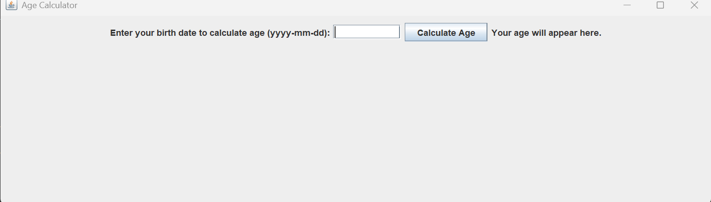

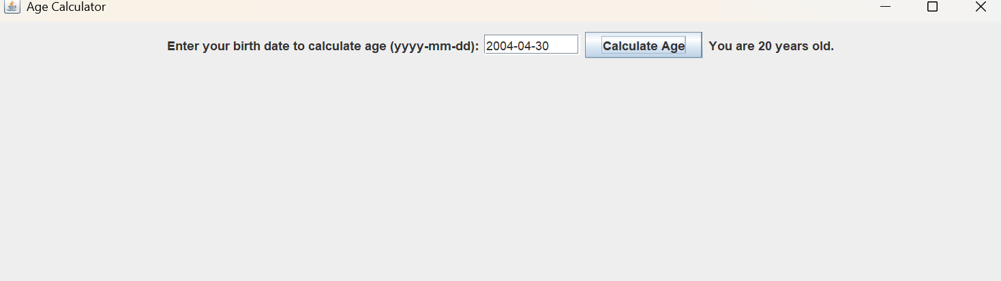

https://github.com/Ebberous/CSC320-1-Critical-Thinking